Practical-10
Secure Login/Logout with Sessions, Role-Based Access, Timeout, and Remember-Me Token
Theory :
- Are sessions started and destroyed securely?
Ans: Yes, sessions are started and destroyed securely during login and logout.

- Is password_verify() used correctly?
Ans: Yes, password_verify() is used to verify passwords securely during login.

- Is unauthorized dashboard access blocked?
Ans: Yes, unauthorized users are prevented from accessing the dashboard without logging in.

- Is session timeout implemented?
Ans: Yes, session timeout is implemented to automatically end inactive sessions.

- Are admin and student users redirected to appropriate dashboards?
Ans: Yes, admin and student users are redirected to their respective dashboards based on their roles.

Result:

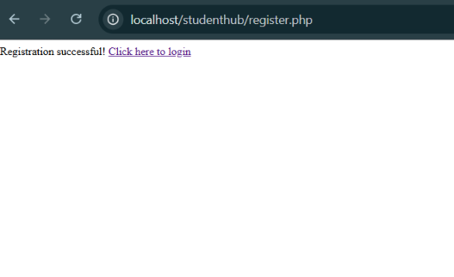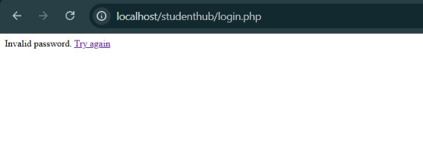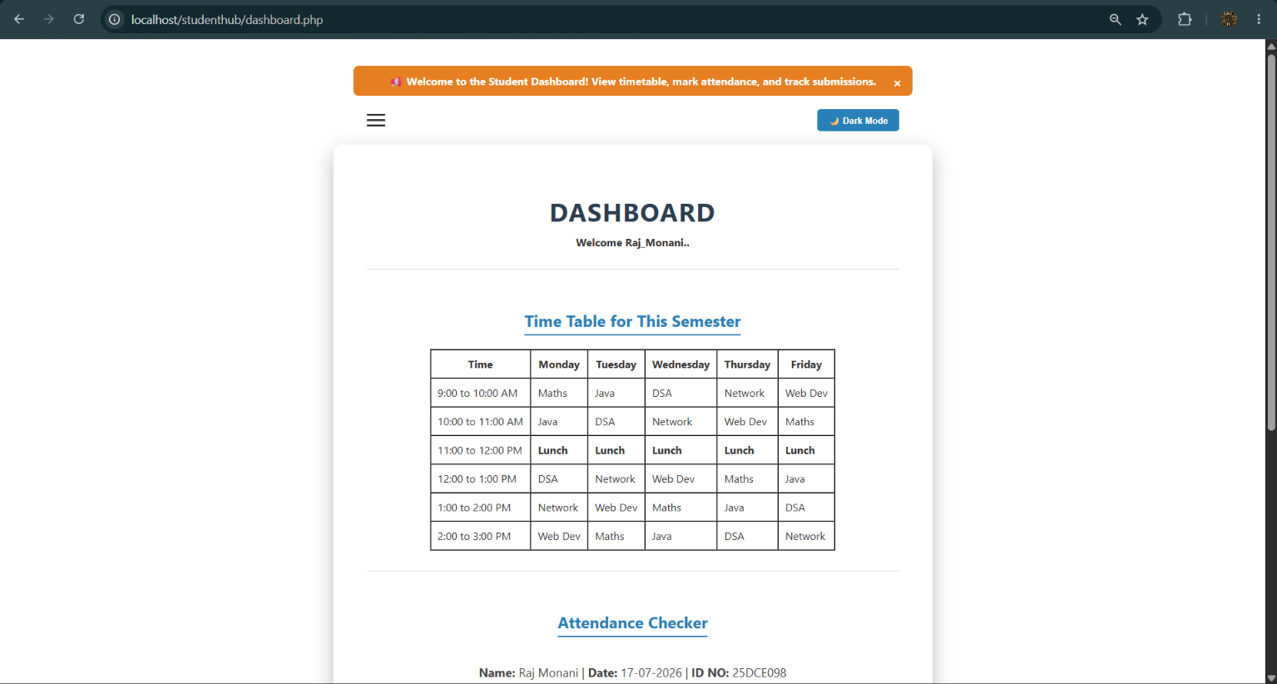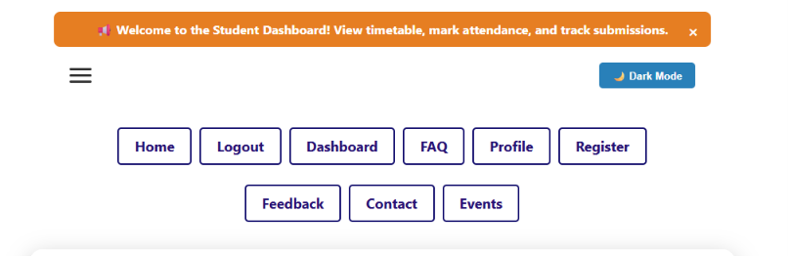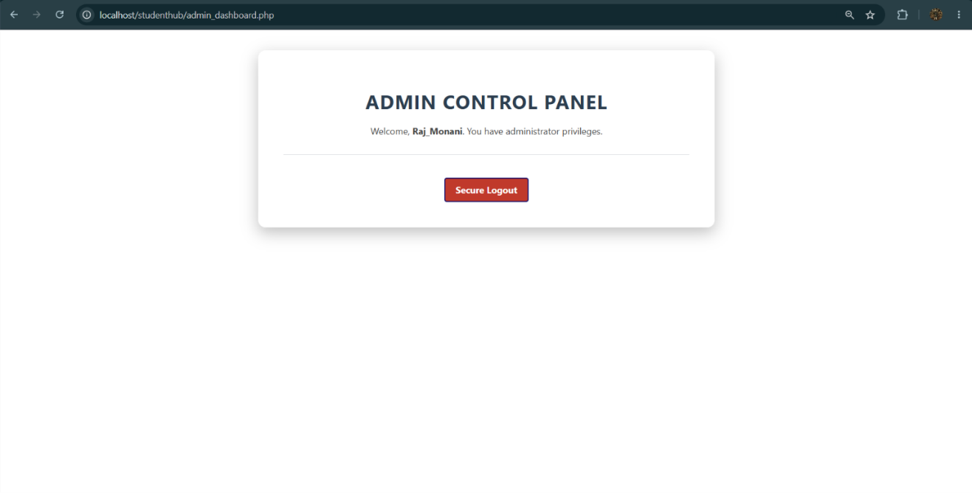

Git Hub Repository Link:
https://github.com/RajMonani/Student-Portal-Hub
Challenges Faced:
I faced difficulties in managing PHP sessions and verifying passwords securely during login. I struggled with restricting unauthorized dashboard access and implementing session timeouts. I also faced challenges in redirecting admin and student users to their respective dashboards.

Learning Outcome:-

I learned to implement secure login and logout using PHP sessions and password_verify(). I understood how to restrict unauthorized access and implement session timeouts. I also learned to manage role-based access and redirect users to the appropriate dashboards.

